Client Name- Fitness First India Pvt Ltd.

Issue- Automation certificate need to renew.

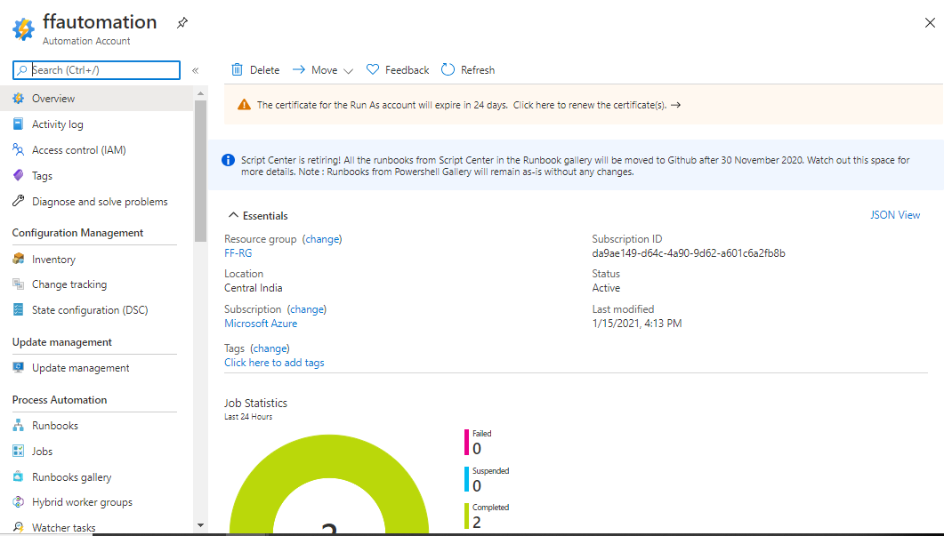

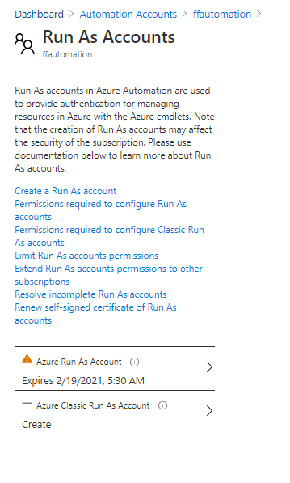

Click on Renew Certificate.
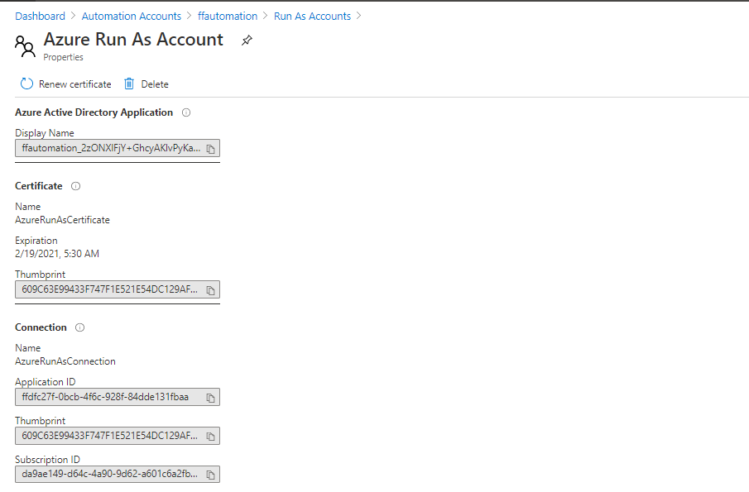

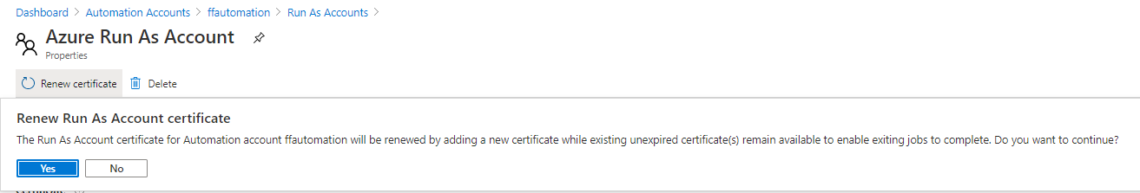
Done

